Frankfort Sunflower Festival 2017

July 28th, 29th, and 30th
Downtown Frankfort Ohio
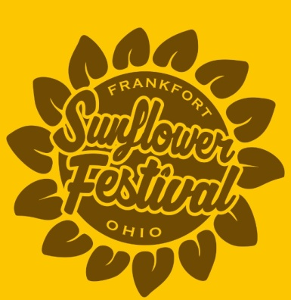

Friday
5:00 Opening Ceremony
Craft Tent and Food vendors open
5:30 Local Groups to include:
Wayne McLaughlin, Missy Thomas, June Wayland,
7:45 Soul’d Out ….southern gospel music

Saturday
8:00 5K Run (Start at Main Stage)
Pancake Breakfast @ firehouse (sponsored by Adena Band Boosters)
8:30 Baby Contest Check-In Registration (main stage)
8-10 Sunflower Show Registration
Baseball Shootout @ Brad Lightle Park sponsored by Adena Youth League
9:00 Craft Tent Opens
Baby Contest (Main Stage)
10:00 Rides and Games Open
12:00 Princess Pageant (Main Stage)
1:00 Sunflower Show winners announced
1:30 Great Seal of Ohio Band
3:30 Grand Parade
4:30 Willow Creek Band
5:30 Pie Auction
6:00 Comedy with Adam Garman
6:30 Takin Back Summer Band
8:30 McGuffey Lane Band

Sunday
8:00 Pancake Breakfast @ firehouse (sponsored by Frankfort History Committee)
8:00- Car Show Registration (West Springfield St.)
Corn hole Registration (front of firehouse)
9:30 Worship and Praise Service (Main Stage)
10:00 Horse Pull Competition @ Brad Lightle Park
Corn hole Tournament
Farmer’s Market open
11:00 Adena Warrior Challenge Course Competition registration (Brad Lightle Park)
Sponsored by Adena Football
11:00 Music by Sodbusters Band
12:30 Kiddie Tractor Pull registration ( main stage area)
1:00 Kiddie Tractor Pull
2:30 Car show Awards and Parade

